

EATING 101
RU DINING HEALTHY?

A WEEKLY NEWSLETTER BROUGHT TO YOU BY THE RU HEALTHY DINING TEAM

A Joint Program Between Rutgers Dining Services and The New Jersey Institute for Food, Nutrition, and Health

Happy (and Healthy) Halloween
Here is a spooky riddle: This holiday brings out the witches, the bats, and the fright, with candy filling the shelves under the moonlit night. What is this? Halloween! This holiday is prime time for horror movies, costume parties, haunted houses, and, of course, plenty of candy. If you plan on celebrating this haunt-filled holiday throughout the last week of October, the Healthy Dining Team is sharing some tricks and treats to keep you healthy this spooky season in the dining halls.
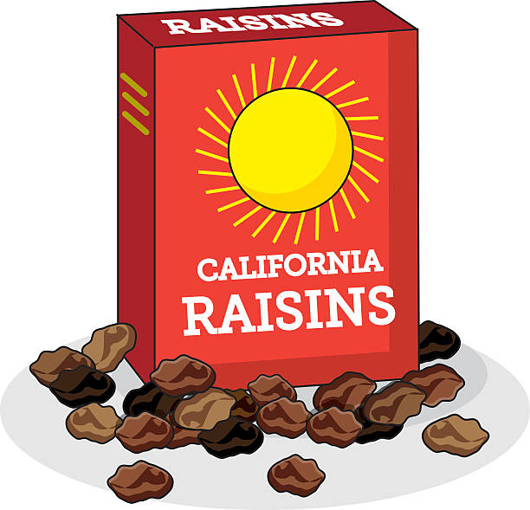

Candy Apples Reimagined:
When your sweet tooth strikes, try this festive apple snack in the dining hall that gives candy vibes without the extra added sugar:

- Slice a Granny Smith apple
- Spread on a tablespoon of peanut butter
- Top it with a drizzle of honey and a dash of cinnamon

Craving Chewy Candy?
Craving that signature Twizzlers® chewiness? Try swapping candy with naturally sweet, dried fruit for that same chewy texture with added fiber, vitamins, and minerals:

- Dining facilities offer a variety of dried fruits, including classic and golden raisins, craisins, and dried apricots




Pumped About Pumpkin Spice?
Warm up with a lower-calorie take on the classic PSL (Pumpkin Spice Latte):

- Start with coffee or espresso
- Add a low-fat milk (fat-free or 1% or try plant-based milk alternatives like almond or soy)
- Use a half-pump of pumpkin spice syrup
- Sprinkle some cinnamon on top
Get Festive with Fall Foods:
Instead of looking to candy corn for a colorful diet, try a candy corn colored plate. Seasonal autumn vegetables offer a festive way to add vibrancy and antioxidants to your meals:

- White: Onions, potatoes, cauliflower
- Orange: Carrots, sweet potatoes, butternut squash
- Yellow: Corn, squash, bell peppers

The haunting truth is that the average American consumes about 100 pounds of sugar each year. That is an average of 143 grams of sugar per day, far exceeding the recommended daily limit of 50 grams. Just one full-size Twix® bar contains 23 grams of sugar, so it can be easy to overdo it. Over time, excessive added sugar intake adds up, which may result in weight gain and increased risk of obesity. An even spookier fact is that eating sugar may leave you craving more. Do not be scared to indulge now and then, but try not to be tricked into making Halloween treats a year-round habit.
Tricks, Treats, and Better for You Eats

Revised by: Chaeli McDonald Reviewed by: Alison H. Brown, MS, RDN-Dining Services

References: “The Question of Sugar”. Available at: https://www.ars.usda.gov/plains-area/gfnd/gfhnrc/docs/news-articles/2012/the-question-of-sugar/. Accessed on: 09/30/26. “Dietary Guidelines for Americans 2026-2030”. Available at: https://www.dietaryguidelines.gov/sites/default/files/2021-11/DGA_FactSheet_AddedSugars_2021-06_508c.pdf. Accessed on: 09/22/26. “The Bitter Truth About Sugar”. Available at: https://www.vailhealth.org/news/the-bitter-truth-about-sugar/. Accessed on: 09/22/26. “Twix Caramel Full Size Candy Bar”. Available at: https://www.twix.com/products/chocolate/twix-bar-bars. Accessed on: 09/22/26. Rutgers Dining Services. Available at: https://food.rutgers.edu Accessed on: 09/22/26. “How to convert grams of sugar into teaspoons.” Available at: https://www.canr.msu.edu/news/how_to_convert_grams_of_sugars_into_teaspoons. Accessed on: 09/30/26.


.
Questions? Like us on Facebook (RU Healthy Dining Team), Instagram (@ru_hdt), or email nutrition@dining.rutgers.edu.

