
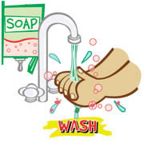
EATING 101

RU DINING HEALTHY?
A WEEKLY NEWSLETTER BROUGHT TO YOU BY THE RU HEALTHY DINING TEAM
A Joint Program Between Rutgers Dining Services and The New Jersey Institute for Food, Nutrition, and Health

RU Food Safe?

Rutgers University Dining Services considers food safety a high priority, as it serves over 3.7 million meals per year to the Rutgers community. Through the combined efforts of the Dining Hall Managers, Staff, University Sanitarian, and the Department of Food Science, Rutgers ensures that your food is not only delicious and nutritious, but also up to safety standards. Students can also join in the effort and take their own steps to ensure the food they consume, take home, or even make, stays safe!

Behind the scenes: How Rutgers Dining keeps your food safe
- All Dining Service Managers are certified by the National Restaurant Association’s “ServSafe” food safety program, which educates on the FDA food code guidelines.
- The University employs a State-licensed Registered Environmental Health Specialist who monitors facilities, trains employees, and ensures compliance with local and state food safety regulations.
- The University’s Food Science Department provides oversight across all dining halls by evaluating food-handling procedures and testing food for microbial quality.

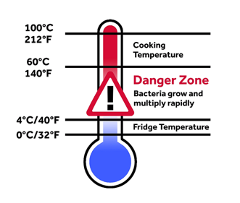

Food Safety Savvy Tips:
- WASH THOSE HANDS: Cut your risk of illness by washing your hands for
at least 20 seconds with warm water and soap before you take that first bite.

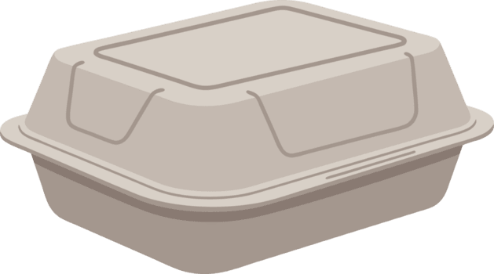
- TIME, TEMPERATURE, AND TAKEOUT: Keep your hot foods like wings,
chicken nuggets, or burgers out of the temperature danger zone, 40-140°F.
If food has been left out at room temperature for more than two hours
(like that pizza left out on the counter overnight), throw it out!

- KEEP IT COLD: Set your micro fridge to 32-40°F to keep your perishable
foods cold. Not sure if your fridge is cold enough? Place a thermometer inside to ensure proper temperature.


- COOKING AND REHEATING: Always check doneness with a food thermometer. Cook chicken to 165°F, ground meats to 160°F, seafood and whole meat cuts to 145°F. When reheating food in the microwave, make sure it reaches an internal temperature of 165°F, and mix it halfway to ensure proper heat distribution and prevent unsafe cold spots.


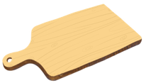
- WASH, RINSE, AND SANITIZE: Clean food contact surfaces after each use by washing with hot soapy water. Utensils or equipment should also be submerged in a sanitizing solution composed of 1 tablespoon of bleach per gallon of cool water. Food contact surfaces may include items such as counters, refrigerators, tables, and thermometers. Use one designated cutting board for raw meat and poultry and another for ready-to-eat foods like produce to prevent cross-contamination. In the refrigerator or when preparing to cook, keep raw foods separate from cooked and ready-to-eat foods.

No Room for Germs This Semester

Revised by: Dustin Nguyen Reviewed By: John Borja, University Sanitarian
References: 4 Steps to Food Safety, https://www.foodsafety.gov/keep-food-safe/4-steps-to-food-safety, Accessed on 9/25/26
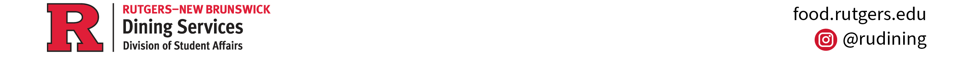
Food Safety Quick Tips: Cook, https://www.fda.gov/media/115449/download, Accessed on 9/26/26
_____________________________________________________________________________________________
Questions? Like us on Facebook (RU Healthy Dining Team), Instagram (@ru_hdt), or email nutrition@dining.rutgers.edu.

